Read this article then answer the questions on the following page in ENGLISH!

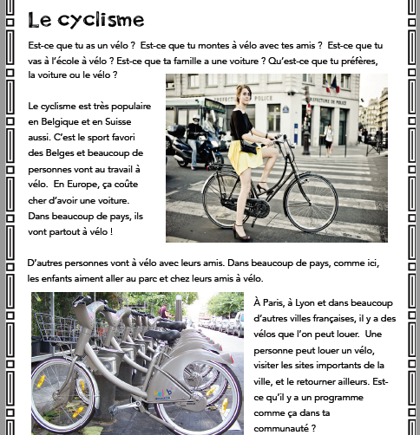

Read the above article and answer the following questions in ENGLISH. This is an interpretive reading assessment. Only use the article to help you and do the best you can.

1. **In English, type below one to two sentences describing what this article is generally about?**
2. **For the following section, read the statements given.**
3. If the statement is TRUE, write TRUE on the space below the statement AND provide proof of your answer.

For example: If the statement says, *There is a picture included in this article*..you would write TRUE and then the proof of that being true would be…. .*there is a photo of a girl on a bike*. So your sentence will look like this..*True, there is a photo of a girl on a bike* (and you should type this in the space below the statement.

1. If the statement is NOT true, leave it BLANK. FYI there will be mostly statements where you need to provide proof as in example (a)!
2. The article asks you personally how you move or get around from place to place? ***(if this is true, provide proof from the article in English by stating what is asked, if it is NOT true leave it blank and go on to the next question. This will be the procedure for all 7 questions).***
3. Riding one’s bike is popular in Europe?
4. It is the favorite sport of people from France?
5. The reason many Europeans choose to ride bikes as a mode of transportation.
6. Places people go with their friends while on their bikes.
7. What people can do in the big cities who do NOT own a bike.
8. The name of a program that support good health in small villages.
9. **Do you think that this mode of transportation is popular in the United States? Why or why not? Explain your answer in a few sentences below by typing to share a cultural comparison (use specific details about why you have that opinion).**